Human eye - 06
CLASS 10 - SCIENCE

 | Section A
1 | Assertion (A): Danger signals are red. Reason (R): Red colour has smallest wavelength.  a) Both A and R are true and R is the correct explanation of A.  b) Both A and R are true but R is not the correct explanation of A.  c) A is true but R is false.  d) A is false but R is true. | [1]
2 | Assertion (A): There is no dispersion of light refracted through a rectangular glass slab. Reason (R): Dispersion of light is the phenomenon of splitting of a beam of white light into its constituents colours.  a) Both A and R are true and R is the correct explanation of A.  b) Both A and R are true but R is not the correct explanation of A.  c) A is true but R is false.  d) A is false but R is true. | [1]
3 | Assertion (A): The blue colour of the sky appears due to the scattering of blue colour. Reason (R): Blue colour has the shortest wavelength in the visible spectrum.  a) Both A and R are true and R is the correct explanation of A.  b) Both A and R are true but R is not the correct explanation of A.  c) A is true but R is false.  d) A is false but R is true. | [1]
4 | Assertion (A): A beam of white light gives a spectrum on passing through a hollow prism. Reason (R): Speed of light outside the prism is different as the speed of light inside the prism.  a) Both A and R are true and R is the correct explanation of A.  b) Both A and R are true but R is not the correct explanation of A.  c) A is true but R is false.  d) A is false but R is true. | [1]
5 | Assertion (A): The bluecolour of the sky appears due to the scattering of blue colour. Reason (R): Blue light has a longer wavelength.  a) Both A and R are true and R is the correct explanation of A.  b) Both A and R are true but R is not the correct explanation of A.  c) A is true but R is false.  d) A is false but R is true. | [1]
6 | Assertion (A): Sunlight reaches us without dispersion in the form of white light and not as its components. Reason (R): Dispersion takes place due to variation of refractive index for different wavelengths but in a vacuum, the speed of light is independent of wavelength and hence vacuum is a non - dispersive medium.  a) Both A and R are true and R is the correct explanation of A.  b) Both A and R are true but R is not the correct explanation of A.  c) A is true but R is false.  d) A is false but R is true. | [1]
7 | Assertion (A): The farthest point up to which the eye can see objects clearly is called the far point of the eye. Reason (R): The nearest point up to which the eye can see objects clearly is called the least point of the eye.  a) Both A and R are true and R is the correct explanation of A.  b) Both A and R are true but R is not the correct explanation of A.  c) A is true but R is false.  d) A is false but R is true. | [1]
8 | Assertion (A): The focal length of the mirror is f and the distance of the object from the focus is u. The magnification of the mirror is $\frac{f}{u}$ . Reason (R): Magnification = $+\frac{Sizeofimage}{Sizeofobject}$  a) Both A and R are true and R is the correct explanation of A.  b) Both A and R are true but R is not the correct explanation of A.  c) A is true but R is false.  d) A is false but R is true. | [1]
9 | Assertion (A): The resolving power of a telescope is more if the diameter of the objective lens is more. Reason (R): Objective lens of large diameter coiled more light.  a) Both A and R are true and R is the correct explanation of A.  b) Both A and R are true but R is not the correct explanation of A.  c) A is true but R is false.  d) A is false but R is true. | [1]
10 | Assertion (A): Danger signals are made of red colour. Reason (R): Velocity of red light in air is maximum, so signals are visible even in dark.  a) Both A and R are true and R is the correct explanation of A.  b) Both A and R are true but R is not the correct explanation of A.  c) A is true but R is false.  d) A is false but R is true. | [1]
11 | Assertion (A): A rainbow is sometimes seen in the sky in the rainy season only when the observer’s back is towards the sun. Reason (R): Internal reflection in the water droplets cause dispersion and the final rays are in the backward direction.  a) Both A and R are true and R is the correct explanation of A.  b) Both A and R are true but R is not the correct explanation of A.  c) A is true but R is false.  d) A is false but R is true. | [1]
12 | Assertion (A): Thin prisms do not deviate light much. Reason (R): Thin prism have small angle A and hence, D $​_{m}$ =  [  ( $μ$ - 1) A  ]  , where $μ$ is the refractive index of prism w.r.t. medium 1.  a) Both A and R are true and R is the correct explanation of A.  b) Both A and R are true but R is not the correct explanation of A.  c) A is true but R is false.  d) A is false but R is true. | [1]
13 | Assertion (A): The human eye is one of the most valuable and sensitive sense organs. Reason (R): Eye enables us to see the wonderful world and the colours around us.  a) Both A and R are true and R is the correct explanation of A.  b) Both A and R are true but R is not the correct explanation of A.  c) A is true but R is false.  d) A is false but R is true. | [1]
14 | Assertion (A): The Sun appears flattened at sunrise and sunset. Reason (R): The apparent flattering of the Sun’s disc at sunrise and sunset is due to atmospheric refraction.  a) Both A and R are true and R is the correct explanation of A.  b) Both A and R are true but R is not the correct explanation of A.  c) A is true but R is false.  d) A is false but R is true. | [1]
15 | Assertion (A): The scattered light makes path of light visible. Reason (R): Scattering of light is the result of Tyndall effect.  a) Both A and R are true and R is the correct explanation of A.  b) Both A and R are true but R is not the correct explanation of A.  c) A is true but R is false.  d) A is false but R is true. | [1]
16 | Assertion (A): In the case of a rainbow, a light at the inner surface of the water drop gets internally reflected. Reason (R): The angle between the refracted ray and normal to the drop surface is greater than the critical angle.  a) Both A and R are true and R is the correct explanation of A.  b) Both A and R are true but R is not the correct explanation of A.  c) A is true but R is false.  d) A is false but R is true. | [1]
17 | Assertion (A): Secondary rainbow is fainter than a primary rainbow. Reason (R): Secondary rainbow formation is a three - step process and hence, the intensity of light is reduced at the second reflection inside the raindrop.  a) Both A and R are true and R is the correct explanation of A.  b) Both A and R are true but R is not the correct explanation of A.  c) A is true but R is false.  d) A is false but R is true. | [1]
18 | Assertion (A): The rainbow is seen when the sun is behind the observer. Reason (R): Rainbow is produced due to dispersion of white light by small rain drops hanging in the air after the rain.  a) Both A and R are true and R is the correct explanation of A.  b) Both A and R are true but R is not the correct explanation of A.  c) A is true but R is false.  d) A is false but R is true. | [1]
19 | Assertion (A): The sky appears dark to people flying at high altitudes. Reason (R): The atmosphere is denser close to the earth.  a) Both A and R are true and R is the correct explanation of A.  b) Both A and R are true but R is not the correct explanation of A.  c) A is true but R is false.  d) A is false but R is true. | [1]
20 | Assertion (A): It is possible to correct the refractive defects with contact lenses or through surgical interventions. Reason (R): The eye lens is composed of fibrous jelly - like material.  a) Both A and R are true and R is the correct explanation of A.  b) Both A and R are true but R is not the correct explanation of A.  c) A is true but R is false.  d) A is false but R is true. | [1]
21 | Assertion (A): You can even see the rainbow during rain. Reason (R): Phenomenon of rainbow occur due to TIR.  a) Both A and R are true and R is the correct explanation of A.  b) Both A and R are true but R is not the correct explanation of A.  c) A is true but R is false.  d) A is false but R is true. | [1]
22 | Assertion (A): A white light passing through a prism splits into its component colours as such that the red light emerges nearest to the base of the prism. Reason (R): The wavelength of red light is more than other component colors and hence, red light deviates least.  a) Both A and R are true and R is the correct explanation of A.  b) Both A and R are true but R is not the correct explanation of A.  c) A is true but R is false.  d) A is false but R is true. | [1]
23 | Assertion (A): Rainbow is an example of the dispersion of sunlight by the water droplets. Reason (R): Light of shorter wavelength is scattered much more than light of larger wavelength.  a) Both A and R are true and R is the correct explanation of A.  b) Both A and R are true but R is not the correct explanation of A.  c) A is true but R is false.  d) A is false but R is true. | [1]
24 | Assertion (A): The sequence of rainbow colour is represented as VIBGYOR. Reason (R): Formation of VIBGYOR sequence colour is due to the dispersion of white light.  a) Both A and R are true and R is the correct explanation of A.  b) Both A and R are true but R is not the correct explanation of A.  c) A is true but R is false.  d) A is false but R is true. | [1]
25 | Assertion (A): Cataract causes partial or complete loss of vision. Reason (R): The eyeball is approximately elliptical shape.  a) Both A and R are true and R is the correct explanation of A.  b) Both A and R are true but R is not the correct explanation of A.  c) A is true but R is false.  d) A is false but R is true. | [1]
26 | Assertion (A): The stars twinkle while the planet do not. Reason (R): The stars are much bigger in size than the planets.  a) Both A and R are true and R is the correct explanation of A.  b) Both A and R are true but R is not the correct explanation of A.  c) A is true but R is false.  d) A is false but R is true. | [1]
27 | Assertion (A): The twinkling of stars is due to the fact that the refractive index of the earth’s atmosphere fluctuates. Reason (R): In cold countries, the phenomenon of looming (i.e., ship appears in the sky) takes place, because the refractive index of air decreases with height.  a) Both A and R are true and R is the correct explanation of A.  b) Both A and R are true but R is not the correct explanation of A.  c) A is true but R is false.  d) A is false but R is true. | [1]
28 | Assertion (A): Danger signals are made of red colour. Reason (R): Wavelength of red is maximum and hence scattering of red colour is minimum.  a) Both A and R are true and R is the correct explanation of A.  b) Both A and R are true but R is not the correct explanation of A.  c) A is true but R is false.  d) A is false but R is true. | [1]
29 | Assertion (A): The twinkling of stars is due to the fact that the refractive index of the earth’s atmosphere fluctuates. Reason (R): When light propagates from one medium to another its direction of propagation changes.  a) Both A and R are true and R is the correct explanation of A.  b) Both A and R are true but R is not the correct explanation of A.  c) A is true but R is false.  d) A is false but R is true. | [1]
30 | Assertion (A): Higher the refractive index of the prism material, lower is the angle of deviation. Reason (R): The angle of deviation is directly proportional to the angle of prism.  a) Both A and R are true and R is the correct explanation of A.  b) Both A and R are true but R is not the correct explanation of A.  c) A is true but R is false.  d) A is false but R is true. | [1]
31 | Assertion (A): The light of violet colour deviates the most and the light of red colour the least, while passing through a prism. Reason (R): For a prism material, refractive index is highest for red light and lowest for violet light.  a) Both A and R are true and R is the correct explanation of A.  b) Both A and R are true but R is not the correct explanation of A.  c) A is true but R is false.  d) A is false but R is true. | [1]
32 | Assertion (A): Sometimes, the eye may gradually lose its power of accommodation. Reason (R): The crystalline lens of people at old age becomes milky and cloudy.  a) Both A and R are true and R is the correct explanation of A.  b) Both A and R are true but R is not the correct explanation of A.  c) A is true but R is false.  d) A is false but R is true. | [1]
33 | Assertion (A): The Sun appears red during sunrise or sunset. Reason (R): The scattering of light is inversely proportional to its wavelength.  a) Both A and R are true and R is the correct explanation of A.  b) Both A and R are true but R is not the correct explanation of A.  c) A is true but R is false.  d) A is false but R is true. | [1]
34 | Assertion (A): The image of a distant object is formed in front of the retina and not at the retina itself. Reason (R): The excessive curvature of the eye lens is a defect of myopia.  a) Both A and R are true and R is the correct explanation of A.  b) Both A and R are true but R is not the correct explanation of A.  c) A is true but R is false.  d) A is false but R is true. | [1]
35 | Assertion (A): A rainbow always appears on the same side as the sun. Reason (R): A rainbow is a natural spectrum that occurs after a shower.  a) Both A and R are true and R is the correct explanation of A.  b) Both A and R are true but R is not the correct explanation of A.  c) A is true but R is false.  d) A is false but R is true. | [1]
36 | Assertion (A): White light is dispersed into its seven - color components by a prism. Reason (R): Different colors of light bend through different angles with respect to the incident ray as they pass through a prism.  a) Both A and R are true and R is the correct explanation of A.  b) Both A and R are true but R is not the correct explanation of A.  c) A is true but R is false.  d) A is false but R is true. | [1]
37 | Assertion (A): The phenomenon of scattering of light by the colloidal particles gives rise to the Tyndall effect. Reason (R): The colour of the scattered light depends on the size of the scattering particles.  a) Both A and R are true and R is the correct explanation of A.  b) Both A and R are true but R is not the correct explanation of A.  c) A is true but R is false.  d) A is false but R is true. | [1]
38 | Assertion (A): A person suffering from myopia cannot see the distant objects clearly. Reason (R): A converging lens is used for the correction of myopic eye as it can form real as well as virtual images of the objects placed in front of it.  a) Both A and R are true and R is the correct explanation of A.  b) Both A and R are true but R is not the correct explanation of A.  c) A is true but R is false.  d) A is false but R is true. | [1]
39 | Assertion (A): The scattering of longer wavelengths of light increases as the size of the particles increases. Reason (R): Large particles scatter lights of all wavelengths equally well.  a) Both A and R are true and R is the correct explanation of A.  b) Both A and R are true but R is not the correct explanation of A.  c) A is true but R is false.  d) A is false but R is true. | [1]
40 | Assertion (A): The sky looks dark and black instead of blue in outer space. Reason (R): There is no air in the outer space to scatter the sunlight.  a) Both A and R are true and R is the correct explanation of A.  b) Both A and R are true but R is not the correct explanation of A.  c) A is true but R is false.  d) A is false but R is true. | [1]
41 | Assertion (A): The curvature of the eye lens can be modified to some extent by the ciliary muscles. Reason (R): The ciliary muscles are used to modify the curvature of lens.  a) Both A and R are true and R is the correct explanation of A.  b) Both A and R are true but R is not the correct explanation of A.  c) A is true but R is false.  d) A is false but R is true. | [1]
42 | Assertion (A): The human eye works like a camera. Reason (R): The human eye’s lens system forms an image on a light - sensitive screen called the retina.  a) Both A and R are true and R is the correct explanation of A.  b) Both A and R are true but R is not the correct explanation of A.  c) A is true but R is false.  d) A is false but R is true. | [1]
43 | Assertion (A): There exist two angles of incidence for the same magnitude of deviation (except minimum deviation) by a prism kept in the air. Reason (R): In a prism kept in the air, a ray is incident on the first surface and emerges out of the second surface. Now if another ray is incident on the second surface (of the prism)along the previous emergent ray, then this ray emerges out of the first surface along the previous incident ray. Theparticle is called the principle of reversibility of light.  a) Both A and R are true and R is the correct explanation of A.  b) Both A and R are true but R is not the correct explanation of A.  c) A is true but R is false.  d) A is false but R is true. | [1]
44 | Assertion (A): The angle through which a ray of light bends on passing through a prism is called the angle of deviation. Reason (R): The peculiar shape of a prism makes the emergent ray bend at an angle to the direction of the incident ray.  a) Both A and R are true and R is the correct explanation of A.  b) Both A and R are true but R is not the correct explanation of A.  c) A is true but R is false.  d) A is false but R is true. | [1]
 | Section B
45 | Study the following ray diagram 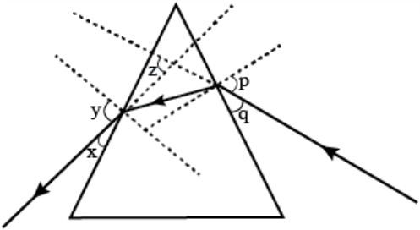  In this diagram, the angle of incidence, the angle of emergence and the angle of deviation respectively have been represented by:  a) p, y, z  b) y, p, z  c) x, q, z  d) p, z, y | [1]
46 | In the following ray diagram the correctly marked angles are: 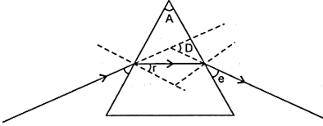  a) $∠$ i and $∠$ e  b) $∠$ r, $∠$ A and $∠$ D  c) $∠$ i, $∠$ e and $∠$ D  d) $∠$ A and $∠$ D | [1]
47 | Study the following figure in which a student has marked the angle of incidence ($∠$ i), angle of refraction ( $∠$ r), angle of emergence ( $∠$ e), angle of prism ( $∠$ A) and the angle of deviation ( $∠$ D). The correctly marked angles are: 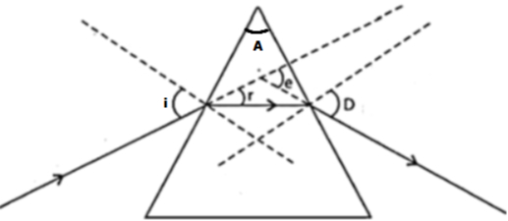  a) $∠$ A, $∠$ i and $∠$ r  b) $∠$ A, $∠$ i, $∠$ r and $∠$ D  c) $∠$ A, $∠$ i and $∠$ D  d) $∠$ A and $∠$ i | [1]
48 | In the following diagram the correctly marked angles are: 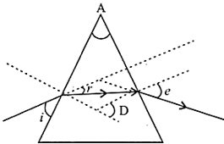  a) $∠$ A, $∠$ i and $∠$ e  b) $∠$ A, $∠$ r and $∠$ D  c) $∠$ i, $∠$ A and $∠$ D  d) $∠$ A and $∠$ e | [1]
49 | What is the relation between angles 1, 2, 3 and 4? 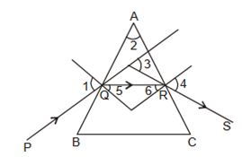  a) + = +  b) + = +  c) + + = +  d) + = + | [1]
 | Section C
50 | Match the following with correct response. 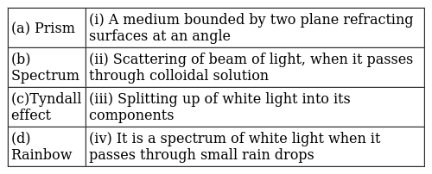  a) (a) - (iv), (b) - (i), (c) - (iii), (d) - (ii)  b) (a) - (i), (b) - (iii), (c) - (ii), (d) - (iv)  c) (a) - (iii), (b) - (ii), (c) - (iv), (d) - (i)  d) (a) - (ii), (b) - (iv), (c) - (i), (d) - (iii) | [1]
51 | Match the following with correct response. 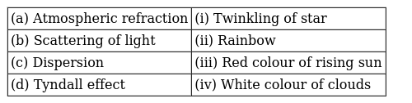  a) (a) - (i), (b) - (iii), (c) - (ii), (d) - (iv)  b) (a) - (ii), (b) - (iv), (c) - (i), (d) - (iii)  c) (a) - (iii), (b) - (ii), (c) - (iv), (d) - (i)  d) (a) - (iv), (b) - (i), (c) - (iii), (d) - (ii) | [1]
 | Section D
52 | Which of the following statements is correct regarding the propagation of light of different colours of white light in air?  a) All the colours of the white light move with the same speed  b) Red light moves fastest  c) Blue light moves faster than green light  d) Yellow light moves with the mean speed as that of the red and the violet light | [1]

